Monthly e-bulletin in the field of Anticorruption

No. 54 - November, 2025
The Role of the National Anti-Corruption Coordinator
The Minister of State for Public Administration and Anti-Corruption, in the role of the National Anti-Corruption Coordinator, coordinates the work on drafting policies and preparing legal and sub-legal acts for the prevention and fight against corruption.
The National Anti-Corruption Coordinator is responsible for conducting verification (administrative investigation) of denunciations/complaints for abusive, corrupt or arbitrary practices for the implementation of legality, as well as identifying employees of institutions, part of the Network of Anti-Corruption Coordinators, who, through actions or inactions, have committed violations of legal/sub-legal acts in force, as well as at the same time developing projects and programs in the field of anti-corruption, planning, coordinating and defining the necessary instruments for the implementation of policies in the field of anti-corruption.
The electronic bulletin is a broad communication tool that aims to inform through the reflection of a summary of the main activities developed by the Minister of State for Public Administration and Anti-Corruption and the General Directorate of Anti-Corruption in the anti-corruption field, on a monthly basis.
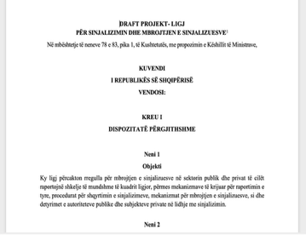
Activities during the month of November, 2025
The Council of Ministers approves the draft law "On whistleblower reporting and protection"
26.11.2025: Approved by the council of Ministers new draft law “On whistleblowing and whistleblower protection”. At the meeting of November 26, 2025 , the Council of Ministers officially approved the draft law, which has now been forwarded to the Albanian Parliament for parliamentary procedures. This draft law is one of the first initiatives of the legal package "Anti-corruption" and aims to guarantee a strong, secure and functional system for reporting violations and suspected cases of corruption in the public and private sectors, protecting whistleblowers from any form of retaliation. The legal initiative consolidates the joint work of the Minister of State for Public Administration and Anti-Corruption in the capacity of the law-proposing minister, the General Directorate of Anti-Corruption and the HIDACCI, as the authority responsible for implementing the law. The approval of the draft law in the Council of Ministers comes after an extensive public consultation process and inter-institutional technical work, which ensured its compliance with the best European standards and specifically the alignment of the EU Directive on whistleblowing as part of the internal anti-corruption legal framework. This step further strengthens the government's commitment to creating an effective and reliable reporting mechanism, in support of public administration and citizens.
The draft law approved by the Council of Ministers can be accessed at the link: https://www.kryeministria.al/newsroom/projektligje-te-miratuara-ne-mbledhjen-e-keshillit-te- ministrave-date-26-nentor-2025/
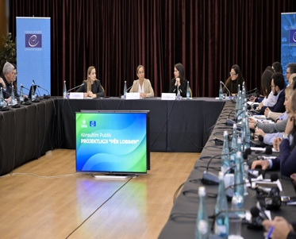
The draft law "On Lobbying" is a new regulatory act of the "Anti-Corruption" package
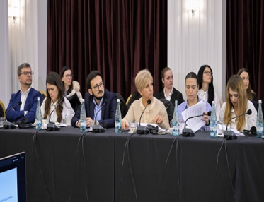
26.11.2025: The drafting of the draft law “On Lobbying” has already entered a new and important phase. After the publication of the initiative in the public consultation register and the collection of comments, a special consultation roundtable was organized, where the proposals and remarks raised by public institutions, the business community, civil society organizations and experts in the field were discussed. The roundtable marked the conclusion of the public consultation process and paved the way for the finalization of the text of the draft law, which aims to bring a contemporary, transparent and standardized framework for the regulation of lobbying activity in Albania. The draft law will guarantee the formalization of contacts between lobbyists and decision-makers, the creation of a Public Lobbying Register, the strengthening of declaration and reporting mechanisms, as well as increased accountability in the processes of policymaking and public administration. The conclusion of this phase consolidates another initiative of the “Anti-Corruption” legal package, further bringing Albania closer to the standards of the Council of Europe Recommendation CM/Rec(2017)2 and the best practices of EU countries in the field of lobbying transparency. The draft law “On Lobbying” is expected to be approved soon by the Council of Ministers.
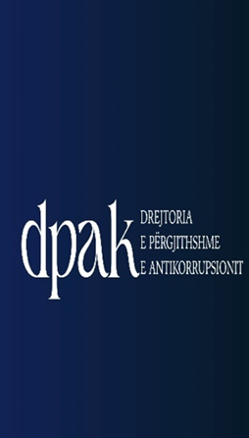
November 2025; The General Directorate of Anticorruption proposes 5 disciplinary measures for public officials
1-30.11.2025: The activity of the General Directorate of Anti-Corruption in the field of investigation and administrative verification continues with the verification of cases (complaints/denunciations) forwarded by citizens and administered by the Directorate of Analysis, Control and Administrative Investigation and the Anti-Corruption Coordinators. During November 2025, 2 final reports were concluded for the Local Directorates of the State Cadastre Agency based on a complete analysis of the facts and documentation administered during the administrative investigation process, and 5 disciplinary measures were proposed for heads, former heads and employees of the institutions where the investigation was conducted. Also, given the role of the General Directorate of Anti-Corruption in terms of corruption prevention, recommendations were proposed, which are based on the principles of sustainable improvement of the institution, management, legal and technical capacities in full compliance with the laws and by-laws in force. The recommendations aim to have a concrete impact on improving systemic issues, which are related to clarifying internal practices, standardizing procedures regarding administrative and organizational aspects, strengthening inter-institutional cooperation, and increasing accountability. In this context, through 2 reports this month, 4 recommendations have been proposed, which in 2 cases address issues of an administrative nature and are related to concrete procedures and in 2 cases address issues of an organizational nature, both in relation to the daily management and internal procedures of the institution.
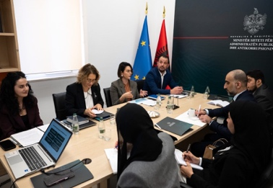
Albania – UAE, exchange of experiences in the field and executive anti-corruption competencies
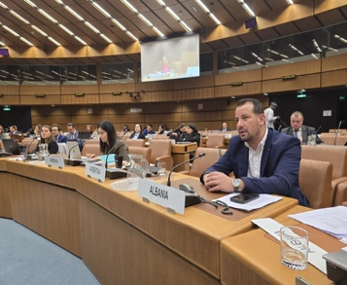
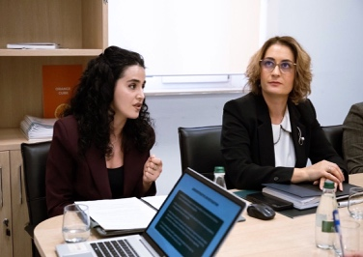
14.11.2025: Bridges of cooperation between the responsible authorities of Albania and the United Arab Emirates are being established in the field of anti-corruption. Representatives of the Minister of State for Public Administration and Anti-Corruption and the General Directorate of Anti-Corruption received in Tirana a delegation of the Accountability Authority of the United Arab Emirates, within the framework of institutional exchange and international cooperation in the field of integrity and good governance. The discussions focused on the exchange of experiences and best practices on building strong integrity systems, strengthening transparency and promoting accountability in public administration. During the meeting, representatives of Albania presented the national anti-corruption framework, including the cross-sectoral approach of the Cross-sectoral Anti-Corruption Strategy 2024–2030, the mechanisms for monitoring implementation, as well as the role of Integrity Plans as guiding instruments in identifying and preventing corruption risks. This meeting marks an important step towards establishing sustainable channels of communication and strengthening inter-institutional cooperation between these two authorities, with the aim of promoting high standards of integrity and increasing public accountability .
International cooperation; Albania participates in the plenary proceedings of IACA
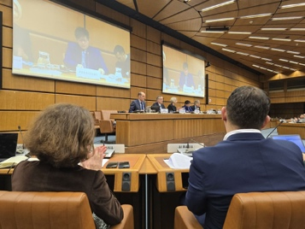
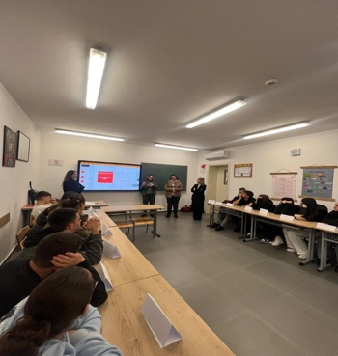
10.11.2025: The General Director of Anti-Corruption, Mr. Insidor Rexhepi, participated in the proceedings of The Fourteenth Session of the Assembly of Parties of the International Anti-Corruption Academy IACA, one of the most important global forums for cooperation and exchange of practices in the field of integrity and good governance. The proceedings of the Assembly reconfirmed the critical role of education, professional training and scientific research in strengthening anti-corruption mechanisms and in supporting the implementation of the Sustainable Development Goals, with a particular focus on building strong, honest and effective institutions. Albania's participation in such international forums underlines its commitment to advance with the best standards of integrity, global cooperation and to actively contribute to international efforts against corruption. The plenary proceedings precede the second global anti-corruption conference, which is expected to be organized at the UN headquarters in New York, USA, where Albania will be present with a state delegation.
Six open information hours on integrity in Tirana high schools
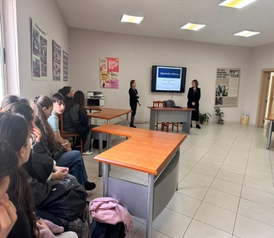
19-26.11.2025: The General Directorate of Anti-Corruption conducted a cycle of six hours open with 10th grade students in several high schools in Tirana, with a focus on building a culture of integrity, ethics and responsible citizenship among young people.
The first meeting (19.11.2025) took place at the "Asim Vokshi" high school, where the importance of ethics, responsible behavior and the culture of law in everyday life was discussed. The students reflected on daily challenges and the ways in which ethical decision-making contributes to building a more just and transparent society.
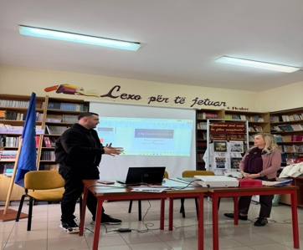
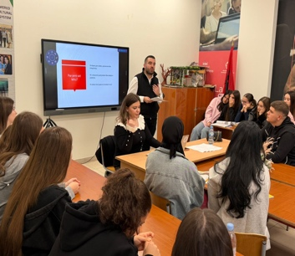
On 20.11.2025, the open hour continued at the "Ismail Qemali" high school, focusing on the fundamental values of honesty, respecting rules, responding to injustices and the role of young people in preventing corruption. The discussions were accompanied by examples from the students' own experiences.
The third meeting (21.11.2025) was held at the "Qemal Stafa" gymnasium, where ethical dilemmas from everyday life, the importance of responding to inappropriate behavior and the need for young people to take an active role in promoting institutional integrity were addressed.
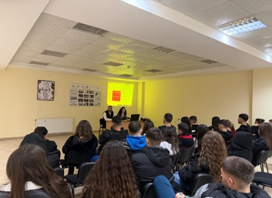
On 25.11.2025, the General Directorate of Anticorruption was in the auditorium of the "Petro Nini Luarasi" high school, where ethics, integrity and knowledge of the law and punishment measures attracted increased interest and increased the knowledge of the students.
On 26.11.202, we concluded the cycle of open hours with sessions held in two schools: “Eqerem Çabej” and “Myslym Keta”. During these meetings, the importance of making honest decisions, strengthening the culture of accountability and the contribution of each student in promoting transparency and ethics in the school community and beyond was emphasized.
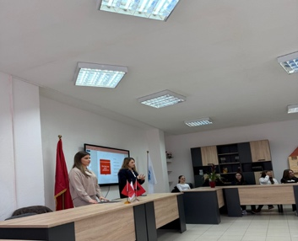
Through discussions, practical cases and open conversation, students were actively engaged, asked questions and brought reflections on concrete situations of school and social life, showing high interest in the topics of integrity and the fight against corruption. The November activities confirm the importance of investing in young people as important actors in strengthening the culture of legality and public integrity. The General Directorate of Anti-Corruption thanks school principals, teachers and especially students for the hospitality, commitment and cooperation shown. The open hours on the fight against corruption based on integrity pave the way for students to become active in the annual Integrity Week campaign, 2025.
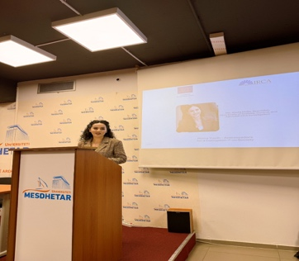
Strengthening the role of Roma youth in the fight against corruption
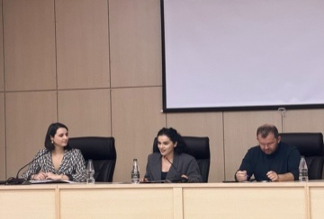
25 & 27.11.2025: The General Directorate of Anti-Corruption participated in the Conference on the topic: "Roma Youth - Ambassadors for a Corruption-Free Society", organized by IRCA (Institute of Romani Culture in Albania), at the auditoriums of the Mediterranean University in Tirana and the "Aleksandër Xhuvani" University in Elbasan. The conference brought together representatives of central and local institutions with a role in preventing corruption, representatives from civil society and academic staff with the aim of discussing topics related to best practices in educating and raising awareness of young people on their role in preventing corruption. The representative of the General Directorate of Anti-Corruption joined the panel on the role of central and local institutions in preventing corruption by presenting the importance of inter-institutional coordination and cooperation, the main developments related to the Cross-Sectoral Strategy against Corruption and its Action Plan, as well as the main activities stemming from the Action Plan related to youth education, teaching curricula and awareness- raising activities. IN school .

