Monthly e-bulletin in the field of Anticorruption
No. 55 - December, 2025
The Role of the National Anti-Corruption Coordinator
The Minister of State for Public Administration and Anti-Corruption, in the role of the National Anti-Corruption Coordinator, coordinates the work on drafting policies and preparing legal and sub-legal acts for the prevention and fight against corruption.
The National Anti-Corruption Coordinator is responsible for conducting verification (administrative investigation) of denunciations/complaints for abusive, corrupt or arbitrary practices for the implementation of legality, as well as identifying employees of institutions, part of the Network of Anti-Corruption Coordinators, who, through actions or inactions, have committed violations of legal/sub-legal acts in force, as well as at the same time developing projects and programs in the field of anti-corruption, planning, coordinating and defining the necessary instruments for the implementation of policies in the field of anti-corruption.
The electronic bulletin is a broad communication tool that aims to inform through the reflection of a summary of the main activities developed by the Minister of State for Public Administration and Anti-Corruption and the General Directorate of Anti-Corruption in the anti-corruption field, on a monthly basis.
Activities during the month of December, 2025
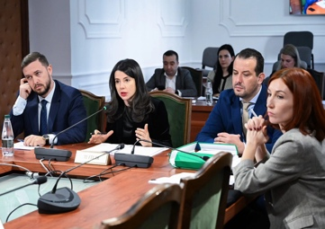
Parliament approves the law "On whistleblowing and whistleblower protection"
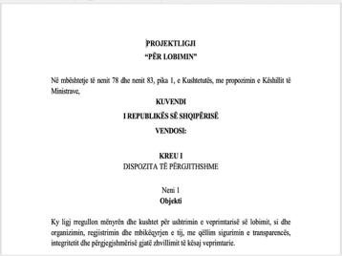
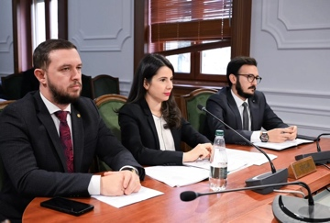
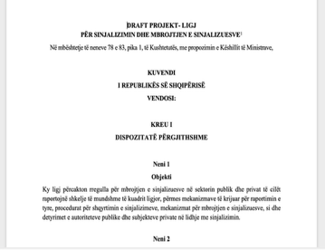
18.12.2025: The Assembly of the Republic of Albania adopted, in the plenary session of 18.12.2025, the new law "On whistleblower protection and whistleblower protection", concluding the legislative process for one of the main acts of the "Anti-corruption" legal package. Since the beginning of December, the draft law was previously subject to review and discussion in the relevant parliamentary committees, where its provisions regarding the protection of whistleblowers and the functioning of reporting mechanisms were analyzed in detail. This law now establishes a comprehensive and unified framework for reporting violations and suspected cases of corruption, in the public and private sectors, guaranteeing effective protection for whistleblowers, maintaining confidentiality and the clear functioning of internal and external reporting channels. The new legal approach aims to strengthen the trust of individuals to report in good faith and significantly increase the institutional capacity to identify and address violations. The adoption of the law by the Albanian Parliament is the result of the joint work of the Minister of State for Public Administration and Anti-Corruption, in the capacity of the responsible minister and proposer of the act, of the General Directorate of Anti-Corruption, in the capacity of the technical authority responsible for drafting the legal framework, and of the HIDACCI as the authority responsible for implementing the law. At the end of an extensive process of public consultation and inter-institutional cooperation and with the completion of the procedures for drafting and approving the law, Albania now has a revised legal framework that ensures compliance with the European Union Directive on whistleblowing and the best European standards, further strengthening the national anti-corruption framework and supporting the European integration process.
The Council of Ministers approves the draft law “On lobbying in the Republic of Albania”
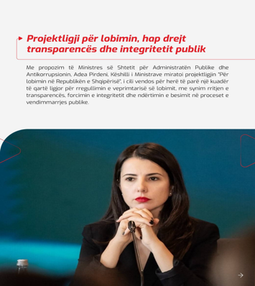
30.12.2025: The new draft law is approved by the Council of Ministers "On lobbying in the Republic of Albania". At the last meeting for 2025, dated 30.12.2025, the Council of Ministers approved officially the draft law thus giving the legal initiative the status of launching parliamentary procedures for the coming months. The draft law aims to create a complete, clear, transparent and controllable framework for regulating lobbying activity, by formalizing contacts between lobbyists and public decision-makers, to establish obligations for declaration and reporting, as well as by creating a Public Lobbying Register. The new legal framework will strengthen transparency, integrity and accountability in public decision-making processes, in the public sector and in the interaction with private interests. The approval by the Council of Ministers is the result of the joint work of the Minister of State for Public Administration and Anti-Corruption, in the capacity of the responsible minister and proposer of the act, and of the General Directorate of Anti-Corruption, in the role and capacity of the technical authority responsible for drafting the legal framework. Following an extensive public consultation process and cooperation with institutional and non-institutional stakeholders, the draft law attracted the attention of many organizations, turning the act into a co-drafted initiative with them. The draft law ensures compliance with the Council of Europe Recommendation and European best practices on lobbying transparency, further strengthening the national anti-corruption framework and supporting the integration process. European.
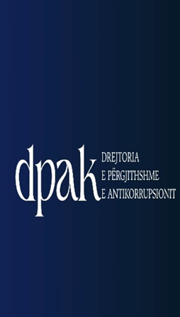
December 2025; The General Directorate of Anti-Corruption proposes 20 disciplinary measures for public officials
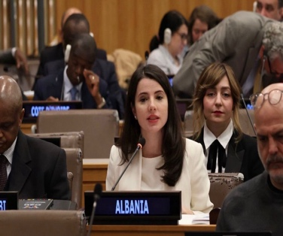
1-31.12.2025: The activity of the General Directorate of Anti-Corruption in the field of investigation and administrative verification continues with the verification of cases (complaints/denunciations) forwarded by citizens and administered by the Directorate of Analysis, Control and Administrative Investigation and the Anti-Corruption Coordinators. During December 2025, 5 final reports were concluded for the Local Directorates of the State Cadastre Agency, the State Inspectorate of Labor and Social Services, and the Albanian Post JSC, based on a complete analysis of the facts and documentation administered during the administrative investigation process, and taking into account the nature of the violation found, the impact it has had on the proper functioning of the respective institution, as well as the degree of individual responsibility of the employees, 20 disciplinary measures were proposed, including heads, former heads and employees of the institutions where the investigation was conducted. In accordance with the preventive role of corruption exercised by the General Directorate of Anti-Corruption, recommendations are proposed, which are based on the principles of sustainable improvement of the institution, management, legal, and technical capacities in full compliance with the laws and by-laws in force. Through the recommendations, the concrete impact on the improvement of systemic issues is aimed, which are related to the clarification of internal practices, the standardization of procedures regarding administrative and organizational aspects, the strengthening of inter-institutional cooperation, as well as increased accountability. In this context, through 5 reports of this month, 32 recommendations have been proposed, which in 25 cases address issues of an administrative nature and are related to concrete procedures, and in 6 cases address issues of an organizational nature, both in relation to the daily management and internal procedures of the institution and in 1 case address issues of a regulatory nature.
Albanian approach to integrity and corruption risk measurement presented at UN anti-corruption conference

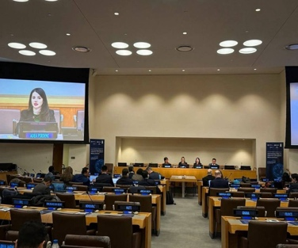
3-5.12.2025: The Minister of State for Public Administration and Anti-Corruption, Ms. Adea Pirdeni, united Albania’s voice and initiatives at the United Nations Global Conference on Measuring the Fight Against Corruption, in New York. The country’s commitment to building evidence-based anti-corruption policies, data for more accurate policies and more integrated and trustworthy public institutions were presented at this event at a global level, where Albania also contributes by exchanging international best practices and positioning itself as an active actor in the development of modern approaches to preventing corruption. Minister Pirdeni was among the speakers at the dedicated panel on innovation and new methodologies in the fight against corruption, presenting the Albanian approach to measuring corruption risk as a key instrument for strengthening integrity in the public service. The shift from perception-based models to structured and evidence-based analyses was also highlighted. Albania also offered its experience with Integrity Plans in force in all central institutions and in 31 municipalities, as well as sectoral risk analyses in areas with high exposure to corruption, such as property, taxation, customs, health, public contracts and education. This is the second edition of the global conference, a joint initiative of the UN, UNODC and IACA, held after two years with the participation of all UN member states.

December 2-16, 2025, "Integrity Week 2025", the 7th annual national edition, will take place.
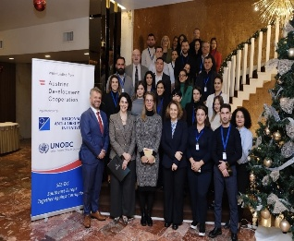
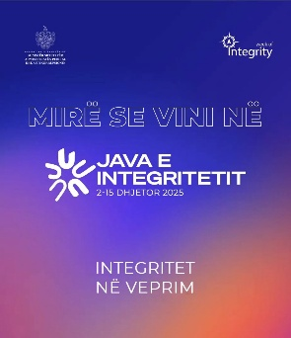
2-16.12.2025: During December 2025, the 7th national edition of the annual campaign “Integrity Week, 2025” was held with public awareness-raising activities and forums on the fight against corruption. This edition was organized under the leadership of the Minister of State for Public Administration and Anti-Corruption, also the National Anti-Corruption Coordinator, with the active involvement of the General Directorate of Anti-Corruption, and the founding co-partner of the campaign, ICC Albania. Other public and non-public organizations, as well as foreign partners in Albania, also became part of it.
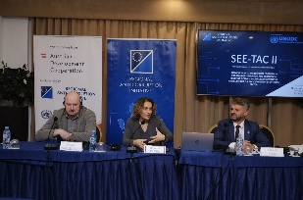
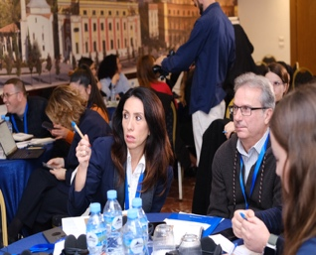
Integrity Week 2025 (2-5.12.2025) was launched with the joint activity of the General Directorate of Anti-Corruption with the Regional Anti-Corruption Initiative (RAI). Two training sessions (two-days) with a focus on strengthening institutional capacities in the field of prevention and fight against corruption for assessing corruption risks and legal frameworks were organized. The first training (2&3.12.2025) was dedicated to technical experts of the Nature Protection and Biodiversity Sector. The training aimed to increase knowledge and practical skills for identifying, analyzing and managing corruption risks in this sector with particular importance for sustainable development and protection of natural resources. Within the framework of this activity, the Guide for Corruption Risk Assessment in the Nature Protection and Biodiversity Sector was presented, accompanied by practical checklists, focusing on its purpose, structure and use in practice. Also, international standards and best practices in the field of corruption risk assessment and during the drafting of legal acts in the field with the relevant methodology were addressed.
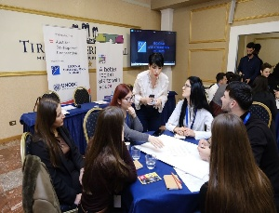
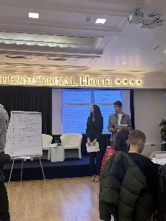
While the second training (4&5.12.2025), was dedicated to technical experts of the Police Sector and the Ministry of Interior and also focused on assessing the risk of corruption and drafting anti-corruption legislation for this sector. The purpose of the training was to strengthen capacities for analyzing the existing legal framework and assessing its compliance with international standards and best practices against corruption. The trainings provided a detailed overview of the methodology for qualifying legislation, the main steps of the process and practical instruments for identifying legal gaps and potential corruption risks. The role of this process in strengthening the rule of law, transparency and public trust in law enforcement institutions was emphasized. In conclusion, both trainings created space for discussion, exchange of experiences and addressing the concrete challenges faced by the relevant institutions, contributing to building an institutional culture based on integrity and effective prevention of corruption.

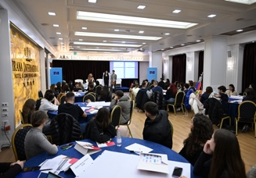
On the International Anti-Corruption Day (9.12.2025), the session on integrity “Strengthening Education for Democratic Citizenship in Albania - Schools for Integrity” was held. The debate “Youth Voice for Integrity”, a joint initiative with the Ministry of Education and the Council of Europe in Tirana. The activity brought together high school students, who developed debate, discussion and interaction formats, creating an open space for dialogue and reflection on the role of young people in promoting integrity, transparency and preventing corruption from the early stages of civic education. During the debate sessions, students expressed their ideas and positions on how they would react to concrete situations of corruption, demonstrating awareness and active commitment to the protection of ethical values. At the end, certificates of participation were awarded to students who participated and were active in the activity.
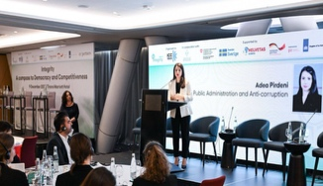
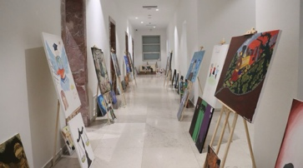
The activities continued on (9-10.12.2025) in the COD hall with the exhibition “Integrity inspires : Youth speak through art ”. This activity brought to attention the artistic creations and messages of young people on integrity and transparency. The exhibition was held as part of the Anti-Corruption Educational Program, which is implemented in cooperation with the Council of Europe and the Ministry of Education, as well. Through the exhibited works, the role of art was put in focus as a clear and honest tool to express the values of integrity and to reflect on the phenomenon of corruption, giving voice to the perspective and civic engagement of young people. Finally, participants had the opportunity to visit the exhibition, exploring the creations and messages of young people and feeling their energy and perspective on a more honest and transparent society.
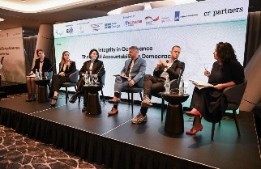
International Anti-Corruption Day (9.12.2025) was marked in Tirana as part of the “Integrity Week” with the development of the conference : “Integrity, A compass towards democracy and competitiveness”, as a platform for discussion and exchange of practices on the key role of integrity and transparency in preventing corruption and strengthening good governance. During the conference, the importance of building and implementing effective integrity mechanisms in the public service was emphasized, as well as the need to increase accountability and transparency in decision-making processes. The discussions also focused on institutional practices that contribute to preventing the risks of corruption, strengthening democracy and increasing the competitiveness of institutions, underlining integrity as an essential prerequisite for public trust and the effective functioning of the rule of law.
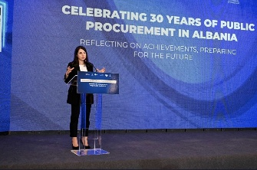
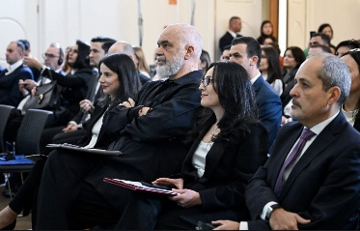
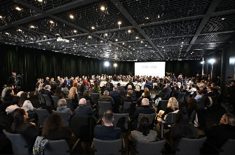
On 11.12.2025, the activity was held within the framework of the 30th anniversary of the Public Procurement Agency , “30 years of public procurement in Albania: Reflections on achievements, preparation for the future ”, organized by the Public Procurement Agency in cooperation with SIGMA, OECD, the World Bank and the Minister of State for Public Administration and Anti-Corruption. During this activity, several technical panels presented the achievements of the main developments as well as the challenges for the future, with topics such as: Integration into the European Union and negotiations for accession for Chapter 5; digitalization and financial intelligence in public procurement, as well as strengthening integrity and professionalism in public procurement. The Prime Minister of the Republic of Albania, representatives from the institutions of the European Union, the head of the Public Procurement Agency, the Minister of State for Public Administration and Anti-Corruption, as well as other actors and representatives of the institutions, participated in this activity. Minister Pirdeni brought to attention the cooperation with the Public Procurement Agency to strengthen the integrity of employees engaged in public procurement; the corruption risk assessment process as a preventive instrument, as well as the certification of every public procurement employee, as a prerequisite for working in this field.
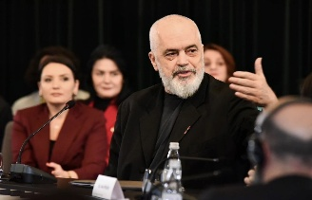
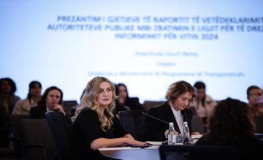
At the conclusion of Integrity Week 2025 (16.12.2025), the 7th National Right to Information Conference was held, with the theme “Transparency Agora in the Time of Integration”, which brought together representatives of public authorities, European partners, civil society and media organizations at a joint table to discuss the old and new dynamics of transparency in the public sector. H.E. Prime Minister Edi Rama honored the conference by placing emphasis on open and public governance. The innovations of the “Transparent Albania” platform, conceived as a unique gateway for proactive transparency, increased access to information and strengthening communication between public institutions and information seekers, in accordance with European standards of open governance, were promoted to the public. The conference reaffirmed the commitment to transparency, accountability and building more open and trustworthy institutions, within the framework of Albania's integration process into the European Union. Part of the conference was the presentation of the technical manual by the General Directorate of Anti-Corruption as an aid in the implementation and monitoring of the Anti-Corruption Strategy.
Throughout Integrity Week 2025, video messages were released from representatives of various public and professional fields, who conveyed clear messages in support of the fight against corruption and strengthening integrity. This campaign contributed to increasing public awareness and involving various stakeholders in promoting the values of transparency, ethics and accountability. Data on any activity (photos and videos) can be found on the social networks of the Minister of State for Public Administration and Anti-Corruption and the General Directorate of Anti-Corruption on Facebook and LinkedIn, as well.
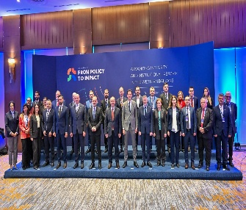
Albania joins the regional forum “From Politics to Impact: Advancing Integrity and Institutional Reforms in the Western Balkans”
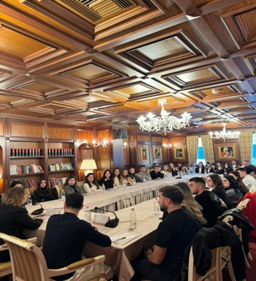
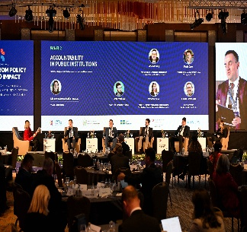
9-10.12.2025: The General Directorate of Anti-Corruption participated in the Regional Forum “ From Policy to Impact: Advancing Integrity and Institutional Reforms in the Western Balkans ”, held in Skopje, Republic of North Macedonia. The Forum brought together senior institutional representatives, regional experts and international partners to discuss strengthening integrity, transparency and accountability in the Western Balkans. The General Directorate of Anti-Corruption contributed to the second panel on “Accountability in Public Institutions – Transforming Policies into Sustainable and Traceable Results”, which emphasized the necessity for anti-corruption policies to be transformed into concrete, measurable and traceable results for citizens. The discussions focused on the systematic follow-up of recommendations, standardization of monitoring processes and increasing the consistency of institutional response, as key elements for strengthening integrity systems. During the intervention, Albania's experience in monitoring the Cross-Sectoral Anti-Corruption Strategy 2024-2030 and its Action Plan 2024-2026 was presented, highlighting the role of inter-institutional coordination, transparency and regular reporting in ensuring the effective implementation of reforms. The forum closed with the adoption of the Skopje Declaration, as a joint regional commitment to advancing integrity and strengthening inter-institutional cooperation in the Western Balkans.
Faculty of Law students in dialogue with the Anti-Corruption Directorate on International Anti-Corruption Day
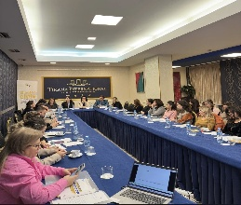
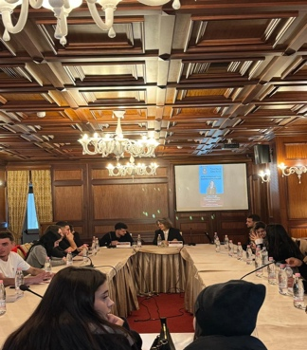
9.12.2025: The International Anti-Corruption Day brings together students from the Faculty of Law of the University of Tirana with the General Directorate of Anti-Corruption. The activity, initiated by the students, highlighted the importance of anti-corruption policies and the role of institutions and young people in building a society with higher integrity. Invited to this activity was Ms. Rovena Pregja, Director of Anti-Corruption Policies at the General Directorate of Anti-Corruption, who shared with the students the main developments of the national anti-corruption framework, current policy priorities and the challenges of their implementation in practice. The discussion focused on areas with high risk of corruption, such as public services, property, public procurement, taxes and customs, as well as on the importance of using indicators and data to measure the effectiveness of preventive measures. In an interactive format, students addressed questions on measuring the results of anti-corruption policies, indicators used to assess institutional performance, as well as the role of educational institutions and students themselves in preventing corruption through education, awareness and civic engagement. Corruption reporting mechanisms and legal guarantees for the protection of whistleblowers were also discussed, as essential elements for building public trust. The activity established bridges of cooperation between the Directorate and future professionals in justice and legal sciences.
Cooperation with civil society is strengthened for consultation on anti-corruption initiatives
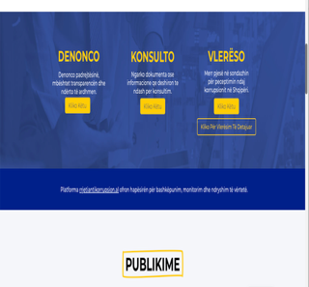
18.12.2025: The General Directorate of Anticorruption participated in the roundtable “Partnership for Integrity and Transparency”, organized by the ALTRI Center, within the framework of the initiative “Civil Society against Corruption – from a Domestic Challenge to a European Response”. Cooperation with civil society and the private sector constitutes a key factor in increasing accountability and transparency in the public sector for the General Directorate of Anticorruption. With this aim, representatives of other public institutions, business, civil society and the media came together and discussed the current challenges of corruption and the needs for strengthening effective cooperation between the actors involved. The activity also served to present the online cooperation platform Rrjetiantikorrupción.al , conceived as a practical tool for cooperation, information exchange and joint action in promoting integrity and preventing corruption. The platform will be another additional communication tool of the General Directorate of Anticorruption with civil society for initiatives and cooperation projects against corruption as a cornerstone to address anti-corruption implementation measures .

