No. 57 - february, 2026
MONTHLY E-BULLETIN IN THE ANTI-CORRUPTION FIELD
The Role of the National Anti-Corruption Coordinator
The Minister of State for Public Administration and Anti-Corruption, in the role of the National Anti-Corruption Coordinator, coordinates the work on drafting policies and preparing legal and sub-legal acts for the prevention and fight against corruption.
The National Anti-Corruption Coordinator is responsible for conducting verification (administrative investigation) of denunciations/complaints for abusive, corrupt or arbitrary practices in the implementation of legality, as well as identifying employees of institutions, part of the Network of Anti-Corruption Coordinators, who, through actions or inactions, have committed violations of legal/sub-legal acts in force, as well as at the same time developing projects and programs in the field of anti-corruption, planning, coordinating and defining the necessary instruments for the implementation of policies in the field of anti-corruption.
The electronic bulletin is a broad communication tool that aims to inform through the reflection of a summary of the main activities developed by the Minister of State for Public Administration and Anti-Corruption and the General Directorate of Anti-Corruption in the anti-corruption field, on a monthly basis.
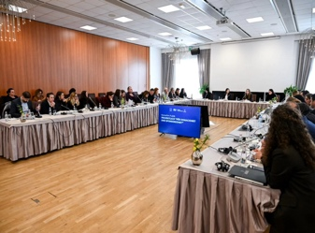
Activities throughout the month of February, 2026
Draft Law "On Donations and Sponsorships" Towards Approval in the Council of Ministers
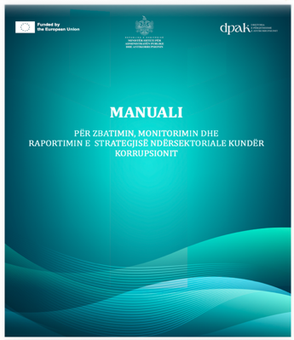
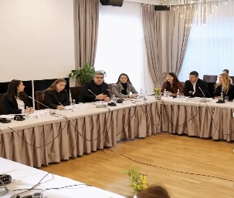

16.02.2026: The Minister of State for Public Administration and Anti-Corruption, Adea Pirdeni, and the Minister of Tourism, Culture and Sports, Blendi Gonxhja, held a public consultation roundtable on the draft law "On Donations and Sponsorships", concluding the consultation phase of this new legal initiative. The draft law comes as a joint initiative of the two ministers, addressing on the one hand the dimension of integrity and prevention of corruption in public administration, and on the other hand the creation of a clear framework for the support and promotion of activities of public interest in the fields of sports, culture and social development, but also other sectors such as social service, social care, education, heritage, environment, human rights. The roundtable brought together representatives of public institutions, civil society organizations, the business community and other interested actors, demonstrating increased interest in this legal initiative. The discussion took place in a spirit of cooperation and transparency, while representatives of civil society organizations appreciated the importance of creating a clear legal framework that enables the support and implementation of projects of public interest. The draft law constitutes the first framework law in this field and aims to establish clear rules for the acceptance, administration and reporting of donations in the public sector, as well as for sponsorships in the fields of sports, culture and art. Through this framework, it is aimed to increase transparency, traceability and accountability at every stage of the process, minimizing the risks of conflict of interest and creating a safer environment for cooperation between the public and private sectors. The draft law “On Donations and Sponsorships” is expected to be forwarded soon for approval by the Council of Ministers.
The Manual for the Implementation, Monitoring and Reporting of the Cross-Sectoral Anti-Corruption Strategy is Approved
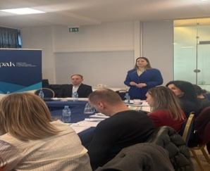
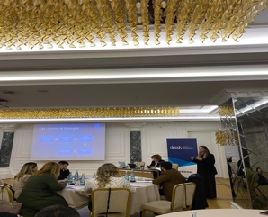
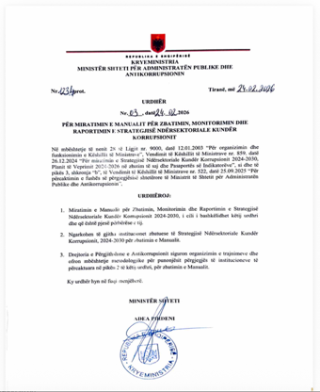
24.02.2026: The Minister of State for Public Administration and Anti-Corruption, Adea Pirdeni, approved the Manual for the Implementation, Monitoring and Reporting of the Cross-Sectoral Anti-Corruption Strategy, the first document of this kind in the country (order no. 3, dated 24.2.2026). The manual creates a unified working framework for all institutions implementing the Cross-Sectoral Anti-Corruption Strategy, standardizing the processes of planning, monitoring and reporting on anti-corruption commitments. Its adoption marks an important step in strengthening institutional mechanisms of coordination and accountability, as well as in ensuring the sustainable and measurable implementation of the strategy. Through this instrument, in the capacity of the National Anti-Corruption Coordinator, Minister Pirdeni consolidates a mechanism that is expected to increase the commitment of institutions and serve as a guarantee for the effective implementation of strategic objectives, in accordance with European standards of integrity and transparency. Following the approval of the Manual, on 24 & 26.02.2026, the General Directorate of Anti-Corruption held dedicated training sessions for members of the Anti-Corruption Contact Points Network from the institutions implementing the strategy. The training focused on introducing the strategic anti-corruption framework, institutional roles and responsibilities in the implementation of the strategy, the stages of planning and monitoring of measures, as well as evidence-based reporting standards, including practical exercises on the implementation of the Action Plan and improving the quality of institutional reporting. The sessions also aimed at strengthening inter-institutional coordination and increasing the practical capacities of the structures responsible for following the measures of the strategy. Ensuring a more sustainable, measurable and evidence-based implementation of anti-corruption policies in public institutions is the key to the success of the implementation of the anti-corruption strategy.
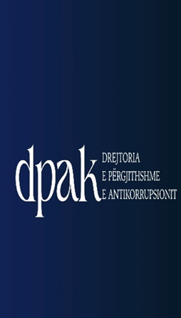
February 2026; The General Directorate of Anticorruption continues the administrative investigation and monitoring of anti-corruption measures
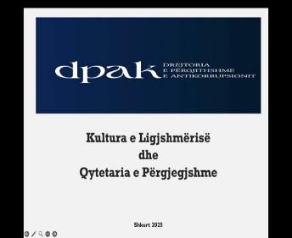
1-28.02.2026: The activity of the General Directorate of Anti-Corruption in the field of investigation and administrative verification continues with the verification of cases (complaints/denunciations) forwarded by citizens. During February, the General Directorate of Anti-Corruption concluded with 6 final reports for the Local Cadastre Directorates on the basis of a complete analysis of the facts and documentation administered during the administrative investigation process. Taking into account the nature of the violation found, the impact it has had on the proper functioning of the respective institution, as well as the degree of individual responsibility of the employees, 11 disciplinary measures have been proposed . Also, given the important role of the General Directorate of Anti-Corruption in terms of corruption prevention, recommendations are proposed, which are based on the principles of sustainable improvement of the institution, management, legal, and technical capacities in full compliance with the laws and by-laws in force. The recommendations aim to have a concrete impact on improving systemic issues, which are related to clarifying internal practices, standardizing procedures regarding administrative and organizational aspects, strengthening inter-institutional cooperation, and increasing accountability. This month, 21 recommendations were proposed, of which 13 address issues of an administrative nature and are related to concrete procedures, and 8 address issues of an organizational nature, both in relation to the daily management and internal procedures of the institution .
" "Education Against Corruption" at the "Naim Frashëri" school in Durrës
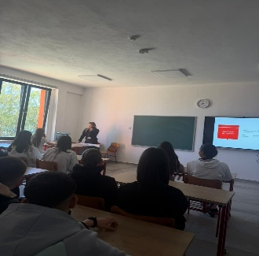
25.02.2026: As part of the “Education against Corruption” project, an open lesson was held at the “Naim Frashëri” high school in Durrës with 10th grade students, on the topic “Culture of Legality and Responsible Citizenship”. The communication and visibility staff at the General Directorate of Anti-Corruption promoted the increase in young people’s awareness of the importance of personal and social integrity, as well as the role that each individual plays in building a just and transparent society. The General Directorate of Anti-Corruption discussed with the students the importance of respecting rules, ethics and civic responsibility in everyday life, emphasizing that education and awareness from an early age are essential elements in preventing corruption. During the discussion, practical cases and concrete situations were addressed, which encouraged the active participation of the students and reflection on the right moral and civic choices. Through open and interactive communication, students were encouraged to express their opinions, discuss the challenges they face in everyday life, and strengthen their role as active and responsible citizens in the community. The open learning hour contributes to strengthening the culture of legality and promoting the principles of the rule of law among the younger generation.

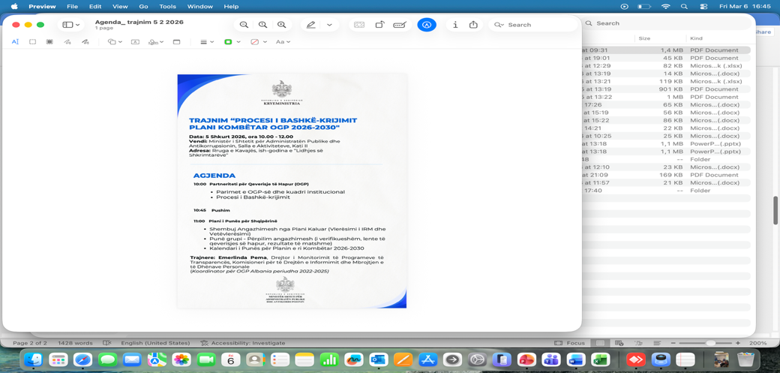
Co-creation of the new National Action Plan for the Open Government Partnership (OGP) 2026-2030
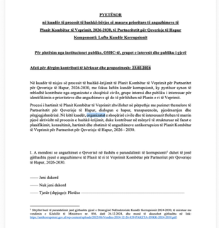
5.02.2026: The Minister of State for Public Administration and Anti-Corruption has launched the process of co-creating the new National Action Plan for the Open Government Partnership (OGP) for the period 2026-2030. Engagement "The fight against corruption" will be part of this plan for the fourth time in a row, reflecting the ongoing priority for strengthening transparency, integrity and accountability in public administration. In this context, more February 5, 2026 An information and training meeting was held with representatives of civil society institutions and organizations on the process of co-creating the new national plan. During the event, the principles of the Open Government Partnership, the process of co-creating commitments, and the work calendar for drafting the National Action Plan 2026-2030 were presented. Meanwhile, during the period February 16-23, 2026 The first phase of public consultation for the component was held “ Fight against corruption” , through the distribution of an open questionnaire to civil society organizations, public institutions, interest groups and the general public. This instrument aims to collect contributions and proposals for identifying priorities and measures to be included in the anti-corruption commitment of the new action plan. The co-creation process is carried out in accordance with the principles of open dialogue, transparency and participation, aiming for new commitments to reflect the real needs of society and contribute to strengthening preventive policies against corruption in public administration.

